192524282-P.SHASHANK
EXP:8
Query with Sub Query& Correlated Query
- Which of the students' scores are greater than the average score? (Subquery)
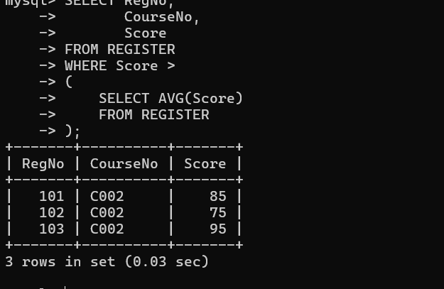

- Which students have written more than one assessment test? (Subquery)
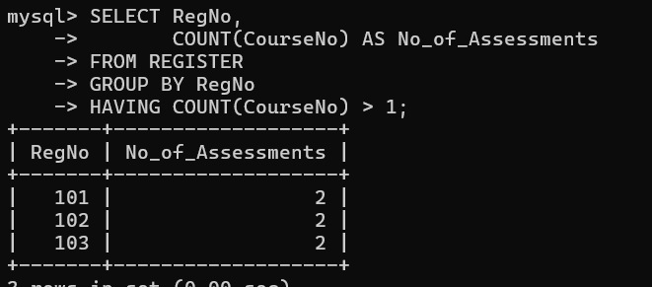

3.Which faculty joined most recently and when?
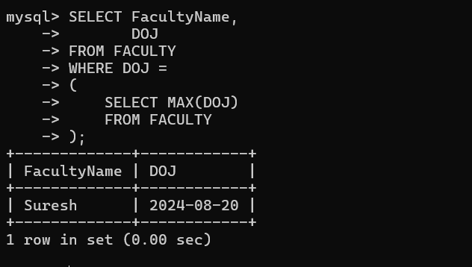
4.List the course and score of assessments that are greater than the average score of their course
